Media release: 08 November 2023

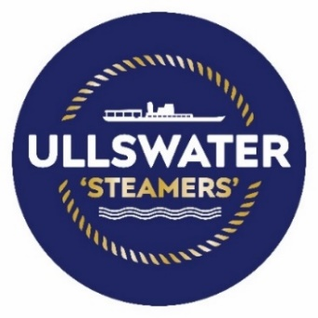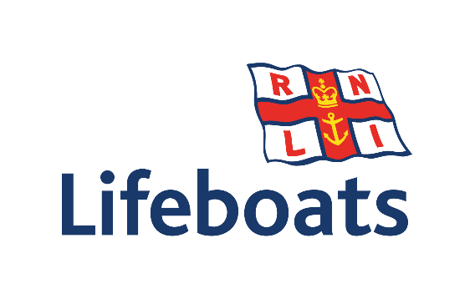

RNLI honours Lake District
visitor attraction

The RNLI (Royal National Lifeboat Institution) has presented ‘Ullswater Steamers’ with a special award for the numerous charity cruises it has hosted on the lake over several decades.

As one of the UK’s best-known charities, the RNLI has been saving lives at sea around the UK’s coastline - and some inland waterways – since the 1820s.

In recent years, ‘Ullswater Steamers’ has welcomed a series of special cruises to help fund the charity’s life-saving work and has now been officially recognised for its contribution.

A VIP presentation at Glenridding Pier saw the Chair of the RNLI’s Penrith Guild, Brenda Couzens present a plaque and framed certificate of appreciation to the company. It was accepted by the President of Ullswater ‘Steamers’, Peter Hensman.

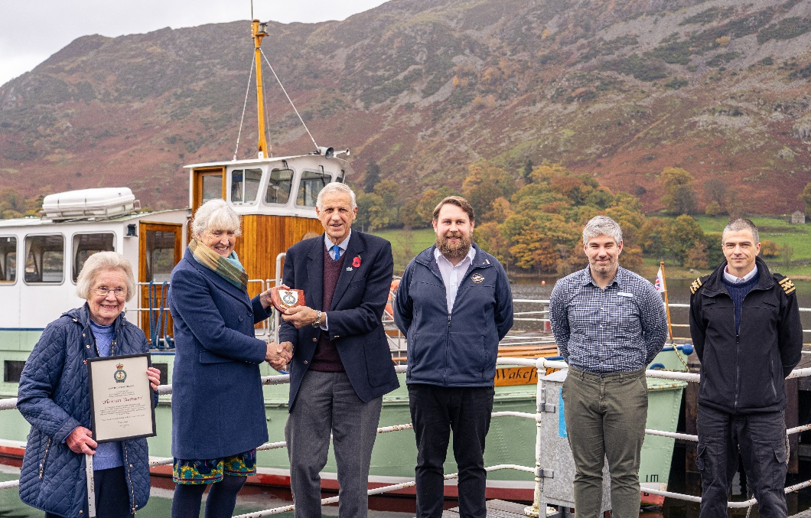

Brenda Couzens says, “I am delighted to present this plaque and certificate of thanks to Ullswater ‘Steamers’ in recognition of their dedicated and longstanding support of the RNLI.

“They have provided the use of one of their ‘steamers’ without charge for charity events at various times over the years, and have facilitated fundraising with an RNLI collection box in their ticket office. Their valued contributions help the RNLI to save lives at sea.”

Peter Hensman adds, “The RNLI is run primarily by volunteers who, through their dedication and skill, save lives both in our region and across the UK. They do a tremendous job and we’re proud to contribute to the vital fundraising efforts which enable their day-to-day work to continue for the benefit of everyone.”

The presentation was also attended by Gillian Relph, who is the Secretary of the Penrith Guild of the RNLI. She was joined by General Manager of Ullswater ‘Steamers’ Callum Smith, Head of Attractions and Retail at Lake District Estates Daniel Morley and Operations Manager at Ullswater ‘Steamers’ Peter Martin.

Ullswater ‘Steamers’ has one of the largest heritage passenger vessel fleets in England and
has been operating in the tranquil Ullswater Valley since 1859. Today, the company provides a sustainable and environmentally friendly way of linking some of the most iconic walking routes and views in the Lake District National Park.

ENDS

Notes to Editors:

Hi res image attached:

- Left-right:

- Brenda Couzens
- Gillian Relph
- Peter Hensman
- Callum Smith
- Daniel Morley
- Peter Martin

For further information and media enquiries, please contact: Cumbria Tourism press office, press@cumbriatourism.org

